READ MORE

TEA BOARD OF KENYA WEBSITE DEMO

SETUP INSTRUCTIONS

Step 1 – The Files are on the Flash Drive
On the Flash Drive you will find a zipped file containing website files and a database file

Step 2 - Upload files to your new domain
Log in via FTP and upload your backup to the web space of your new domain. If you made your backup with File Manager, don't forget to unzip it before uploading.
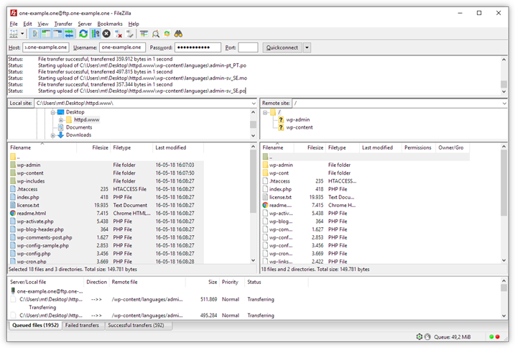
You can upload the website files Via CPANEL from the flash disk

Step 3 - Import your database
Import the backup of your database to phpMyAdmin. Check out our guide on how to import a database, if you would like some help.

Step 4 - Go to wp_options
Once your database has been imported, locate the table called wp_options in the menu to the left.
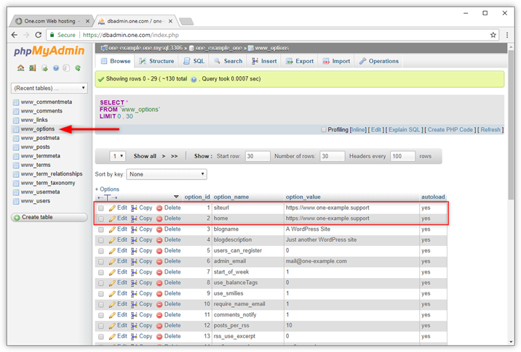

Step 5 - Update siteurl and home
Next, you need to change the location of your site in the database.
- In wp_options, locate siteurl and home. Usually, these records are at the top of the table on line 1 and 2.
- For siteurl, click the field under option_value and replace the old domain with your new domain name.
- Press enter to save.
- Do the same for home.

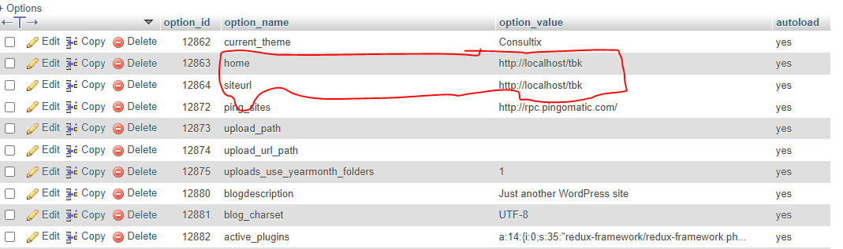

Step 6 - Import your database
Import the backup of your database to phpMyAdmin. Check out our guide on how to import a database, if you would like some help.

Step 7 - Update connection details in wp-config
You now need to replace the login details from your old domain, with those of your new domain in WordPress.
We have created a guide on how to update the connection details in case you need some help.

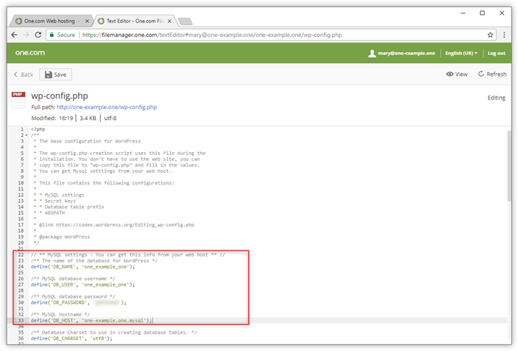

Step 10 - Fix permalinks (Optional)
If you experience that you get a 404 error when you try to open links on your site, the Permalinks are broken. Luckily it is very easy to fix this.
- Log in to your WordPress dashboard.
- Click Settings and then Permalinks
- Scroll down and click Save Changes.
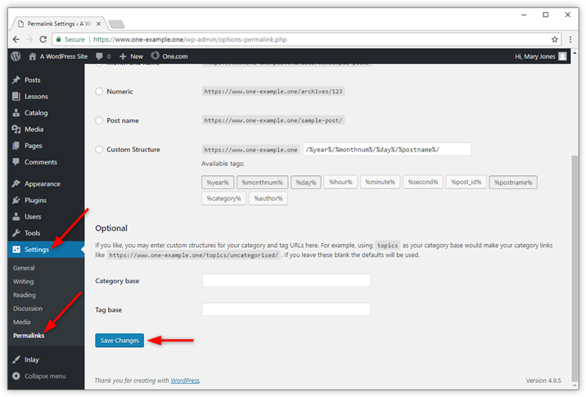

Step 11 - Fix broken images (Optional)
If you experience that images don't show correctly, this means that the links are still referring to the old domain. You can fix this by reinserting images manually.
When you have a website with a lot of images you can try a plugin called Better Search Replace. It automatically replaces your old domain with your new domain in your database.

- Log in to your WordPress dashboard.
{Username: admin Password: @tbk_2022#}
- Click Plugins and then Add new.
- Search for Better Search Replace and install the plugin with that name.
- Click Activate to make the plugin active.
- Click Tools and Better Search Replace.
- Search for the old domain name and Replace with the new domain name.
- Select the tables that you want to search in. Your posts are located in the table wp_posts, but usually you can safely select all tables.
- Uncheck the box for Run as dry and click Run Search/Replace. If you want to do a test run before making changes, leave the box for Run as dry checked.
